# Simultaneous Thermogravimetric Analyzer STA7000 Series

窗体顶端

窗体底端

* [Request Info](https://www.hitachi-hightech.com/us/product_detail/?pn=ana-sta7000)
* [Print](javascript:void(0))

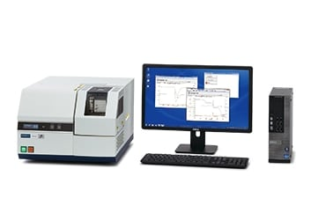

The STA7000 Series Simultaneous Thermogravimetric Analyzer provides simultaneous measurement of both TG and DTA/DSC with a wide temperature range.  
The horizontal dual beam design ensures highly accurate and precise data enabling it to detect microgram-level gram level weight change.

**New Balance Control Technology**

The newly-developed "Horizontal Digital Dual Beam System" provides higher baseline stability and lower noise levels, than the conventional TG models. Digitally processed signals are automatically corrected and provide stable data.

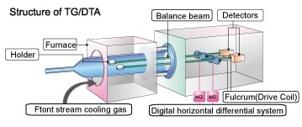

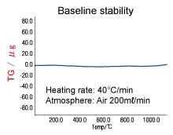

**New Temperature Control Functions**

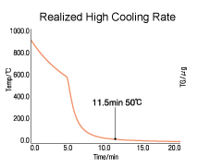

This revolutionary temperature control circuit minimizes the temperature difference between program and sample temperrature.The heating and cooling rate accuracy further improve the quality of the DTA/DSC and TG signal and guarantee high precision temperature readings.

**High-Throughput Measurement with a Wide Range of Options**

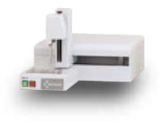

The Autosampler and Mass Flow Controller improve the effectiveness of measurement. New autosampler accommodates up to 50 samples.

**"Real View STA" Sample Observation Option**

Real View STA displays and saves the changes of samples during a measurement in continuous images. After the measurement, you can load the saved images by using the diagnosis software to display and analyze the images at each corresponding temperature and signal. When evaluating thermal decomposition, this option provides more reliable information.  
The Digital Zoom Function provides information of minute change of the sample. In addition, the Length Measurement Function measures the length of the sample before and after the shape change.

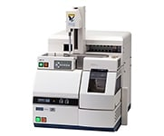  
STA7200RV+RV-3TG+AS-3T

* **\* RV-3 is not available for sell in Europe at the moment.**

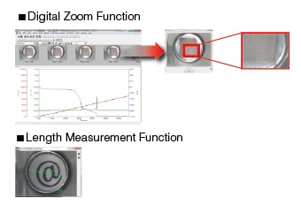  
Real View STA Data

## [Applications](https://www.hitachi-hightech.com/us/product_detail/?pn=ana-sta7000#productSub-2)

|  |  |  |  |  |
| --- | --- | --- | --- | --- |
| Model | STA7200 standard type | STA7200RV for sample observation | STA7300 High Temperature Type | AS-3T Auto Sampler Unit |
| Temperature Range | Ambient to 1,100°C | Ambient to 1,000°C | Ambient to 1,500°C | - |
| Balance Type | Horizontal Differential Type | | | - |
| TG Measurement Range | ±400 mg | | | - |
| TG Sensitivity | 0.2 µg | | | - |
| DTA Measurement Range | ±1,000 µV | | | - |
| Scan Rate | 0.01 to 150°C/min | | 0.01 to 100°C/min | - |
| Purge Gas Flow Rate | 0 to 1,000 ml/min | | | - |
| Cooling Time | 1,000 to 50°C Within 20min(Auto Fan Cooling),  12min(Forced Air Cooling) | | | - |
| Number of Samples | - | | | Max. 50 |

### Thermal decomposition of Polymers

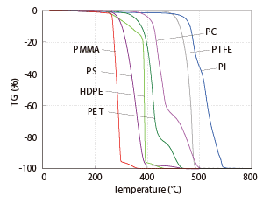

This is comparison of TG result of various polymers. It shows that thermal decomposition behavior differs by polymer type.

### TG/DSC measurement of Polyethylene terephthalate (PET)

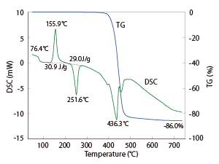

DSC result shows the calorimetric analysis for crystallization and melting and TG shows weight change by thermal decomposition.

### TG-MS analysis of Fullerene

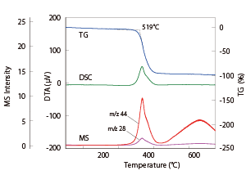　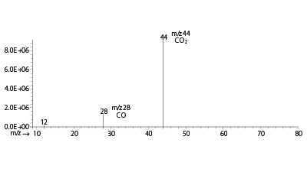

Weight loss was detected by TG at around 520°C and the evolved gas was identified by MS as CO and CO2.